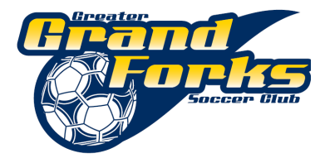

Greater Grand Forks Grand Forks Soccer Club Meeting
October 14th, 2012
Red River Rider Room

Present: Eric Myrold, Paula Leake, Byron Stancliff, Joan Huus, Karna Loyland, Kathy Rustebakke, Vicky Black, Jeanine Swartz, Julie Vorachek, Patty Olsen, Kara Brewer, Denise Simon

Absent: Teresa Blisle

Introductions:

Treasure’s Report: will share next board meeting
Should we consider a sponsor?

Registrar Report: as of today
46 boys registered
19 girls registered

Public Comment: N/A

4. Unfinished Business / New Business:
DOC-Leads: Luke Glasoe, Tash Brewer; discuss more at November meeting
League: Much discussion still happening at the league level. Possible league tournament at the end of July. 14 teams have currently joined ND league as of today.
Tournaments: July 21^{st-} - 23rd Tri-City Tournament (Fargo, ND)
November meeting we will discuss our tournaments further. June 7-9
Survey:
Club Affiliation:
5. Other:
Coaches licensing clinics
Player clinics
Indoor soccer
Representation at the Sunflake Soccer meetings
Kara Brewer will be liason between Sunflake Soccer and GGFSC
Club should follow a model of coaching and playing

5. Next Board meeting:

6. Meeting adjourned at PM by unanimous consent.

Respectively Submitted,

Joan Huus,
Secretary-Greater Grand Forks Soccer Club

